Practical 2

**Q1.1** Write HTML code to design the form which has username and password field.

Code:

<html>

<head>

<title> 1.1 </title>

</head>

<body>

<form name=form1>

Username<input type="text" name="text1"><br>

Password<input type="password" name="pwd"><br>

</form>

</body>

</html>

Output:

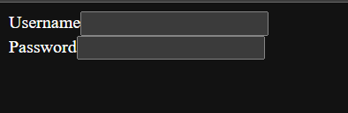

**Q1.2** Write HTML code to design the form which has username, password, submit and reset buttons field.

Code:

<!DOCTYPE html>

<html lang="en">

<head>

    <meta charset="UTF-8">

    <meta http-equiv="X-UA-Compatible" content="IE=edge">

    <meta name="viewport" content="width=device-width, initial-scale=1.0">

    <title>1.2</title>

</head>

<body>

    <form name=form1>

        Username<input type="text" name="text1"><br>

        Password<input type="password" name="pwd"><br>

        <input type="submit" value="Submit">

        <input type="reset" value="Clear">

        </form>

</body>

</html>

Output:

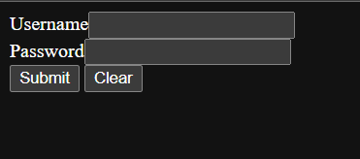

2

Code:

<!DOCTYPE html>

<html lang="en">

<head>

    <meta charset="UTF-8">

    <meta http-equiv="X-UA-Compatible" content="IE=edge">

    <meta name="viewport" content="width=device-width, initial-scale=1.0">

    <title>2</title>

</head>

<body>

    <form name="form1" action="thank.html" method="post">

        Username<input type="text" name="text1"><br>

        Password<input type="password" name="pwd"><br>

        <input type="submit" value="Submit">

        <input type="reset" value="Clear">

        </form>

</body>

</html>

Output:

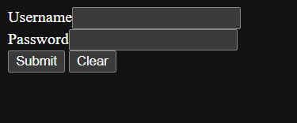

3

Code:

<!DOCTYPE html>

<html lang="en">

<head>

    <meta charset="UTF-8">

    <meta http-equiv="X-UA-Compatible" content="IE=edge">

    <meta name="viewport" content="width=device-width, initial-scale=1.0">

    <title>3</title>

</head>

<body>

    <form name="form1" action="thank.html" method="post">

        Address<textarea rows=5 cols=5></textarea><br>

        <input type="submit" value="Submit">

        <input type="reset" value="Clear">

        </form>

</body>

</html>

Output:

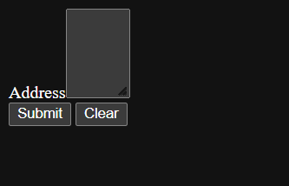

4

Code:

<!DOCTYPE html>

<html lang="en">

<head>

    <meta charset="UTF-8">

    <meta http-equiv="X-UA-Compatible" content="IE=edge">

    <meta name="viewport" content="width=device-width, initial-scale=1.0">

    <title>4</title>

</head>

<body>

    <form name="form1">

        Address<textarea rows=2 cols=5></textarea><br>

        Do you want your response copy...?<br>

        <input type="checkbox" name="cb">Yes

        <input type="checkbox" name="cb1">No<br>

        <input type="submit" value="Submit">

        <input type="reset" value="Clear">

    </form>

</body>

</html>

2 <html>

<head>

    <title> form demo </title>

</head>

<body>

    <form name="form1">

        Address<textarea rows=2 cols=5></textarea><br>

        Select Course?<br>

        <input type="checkbox" name="cb">CS

        <input type="checkbox" name="cb1">IT<br>

        <input type="submit" value="Submit">

        <input type="reset" value="Clear">

    </form>

</body>

</html>

Output:

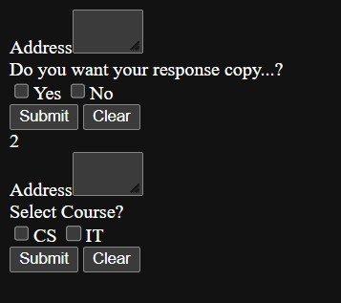

5

Code:

<!DOCTYPE html>

<html lang="en">

<head>

    <meta charset="UTF-8">

    <meta http-equiv="X-UA-Compatible" content="IE=edge">

    <meta name="viewport" content="width=device-width, initial-scale=1.0">

    <title>5</title>

</head>

<body>

    <form name="form1">

        Do you like fruits..?<br>

        <input type="radio" name="r">Yes

        <input type="radio" name="r">No<br>

        <input type="submit" value="Submit">

        <input type="reset" value="Clear">

        </form>

</body>

</html>

Output:

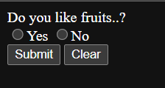

6

Code:

<!DOCTYPE html>

<html lang="en">

<head>

    <meta charset="UTF-8">

    <meta http-equiv="X-UA-Compatible" content="IE=edge">

    <meta name="viewport" content="width=device-width, initial-scale=1.0">

    <title>6</title>

</head>

<body>

    <form>

        Name<input type="text" name="n"><br>

        Email<input type="text" name="e"><br>

        Do you like fruits..?<br>

        <input type="radio" name="r">Yes

        <input type="radio" name="r">No<br>

        Favourite fruit..?<br>

        <select type="Fruit list"><br>

        <option>Apple</option>

        <option>Banana</option>

        <option>Watermelon</option>

        <option>Mango</option>

        </select><br>

        How many pieces do you eat per day...?<br>

        <input type="radio" name="r">1

        <input type="radio" name="r">2

        <input type="radio" name="r">3<br>

        Do you want your response copy...?<br>

        <input type="checkbox" name="cb">Yes

        <input type="checkbox" name="cb1">No<br>

        <input type="submit" value="Submit">

        <input type="reset" value="Clear">

        </form>

</body>

</html>

Output:

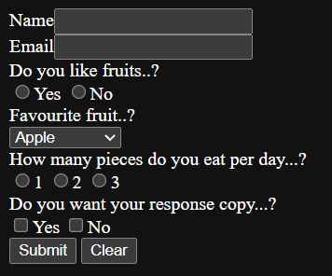

7

Code:

<!DOCTYPE html>

<html lang="en">

<head>

    <meta charset="UTF-8">

    <meta http-equiv="X-UA-Compatible" content="IE=edge">

    <meta name="viewport" content="width=device-width, initial-scale=1.0">

    <title>7</title>

</head>

<body>

    <form name="form1">

        Enter your email<input type="email" name="eid"><br>

        <input type="submit" value="Submit">

        <input type="reset" value="Clear">

        </form>

</body>

</html>

Output:



8

Code:

<!DOCTYPE html>

<html lang="en">

<head>

    <meta charset="UTF-8">

    <meta http-equiv="X-UA-Compatible" content="IE=edge">

    <meta name="viewport" content="width=device-width, initial-scale=1.0">

    <title>8</title>

</head>

<body>

    <form name="form1">

        <input type="image" src="AL2.jpg" alt="Aurora Lights" height="650px" width="1400px">

        </form>

</body>

</html>

Output:

